Sharon’s English School © 058-980589 08-9436545

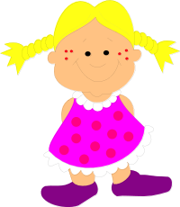
כתבו בכל משפט את שם הגוף המתאים:

He, She, It, We, They

Gal is my friend.
____________ is in my class.

Shira is in our class.
____________ is a good pupil.

Gal and I like school.
____________ are good pupils too.

Gill and I have dogs.
____________ have green eyes.

Raz and his friend like sports.
____________ play football.

Hila has a new doll.
____________ is pink.

השלימו את המשפטים בעזרתam,is,are :

The girl ________ thin.
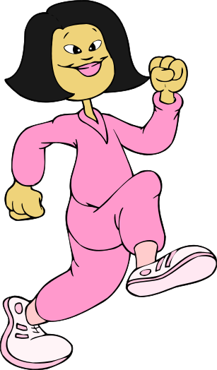
The woman ________ fat.
The house ________ white.
The books ________ new.
The shoes ________ big.
The windows ________ open.
The trees ________ tall.
The girls ________ happy.
Th man ________ sad.
The man ________ angry.

